# SQLExportStep

**Objective:**

It is used to export data from the selected database.

**Attributes**:

|  |  |
| --- | --- |
| **Attributes** | **Description** |
| value | To enter the query to execute |
| value_type | To select type as free marker template or handlebar |
| plugin_name | To connect with mysql server based on the plugin credentials |

**Sample config.json:**

{

"workflows":[

{

"name":"sql_export",

"id":1828,

"trigger":"rest",

"expression":"/sqlexport",

"method":"GET",

"steps":[

{

"type":"start",

"id":1,

"next":{

"start":"2"

}

},

{

"id": "2",

"type": "sql-export",

"value":"select * from test",

"value_type": "hb",

"plugin_name": "user_mysql",

"next":{

"success": "3",

"failure": "hangup"

}

},

{

"http_response_code":"200",

"response_content_type":"application/json",

"value_type":"hb",

"type":"send",

"id":"3",

"next":{

"success":"hangup",

"failure":"hangup"

}

}

]

}

],

"filters":[],

"server":{},

"plugins":[

{

"id": 243,

"name": "user_mysql",

"type": "mysql-plugin",

"version": "1.0",

"category": "Database",

"server": "localhost",

"username": "root",

"password": "root",

"schema": "testDB"

}

]

}

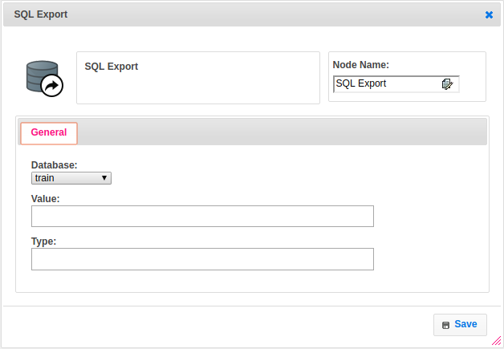

**Executor Description:**

In executor class first it will execute the sql query based on the plugin credentials and get the from respective database then store into result set. Create a file and print the resultset data into that file by using csv printer as per headers in csv format and returns step status as success.